Assignment-7.4
Task01: Task 1: Debugging a Recursive Calculation Module
Scenario You are maintaining a utility module in a software project that performs mathematical computations. One function is meant to calculate the factorial of a number, but users are reporting crashes or incorrect outputs.
Task Description :You are given a Python function intended to calculate the factorial of a number using recursion, but it contains logical or syntactical errors (such as a missing base condition or incorrect recursive call).
Use GitHub Copilot or Cursor AI to:
- Analyze the faulty code
- Identify the exact cause of the error
- Suggest and apply corrections to make the function work
Correctly Document how the AI detected the issue and what changes were made. Expected Outcome
- A corrected recursive factorial function
- AI-generated explanation identifying: o The missing or incorrect base case o The corrected recursive logic
Sample input/output demonstrating correct execution
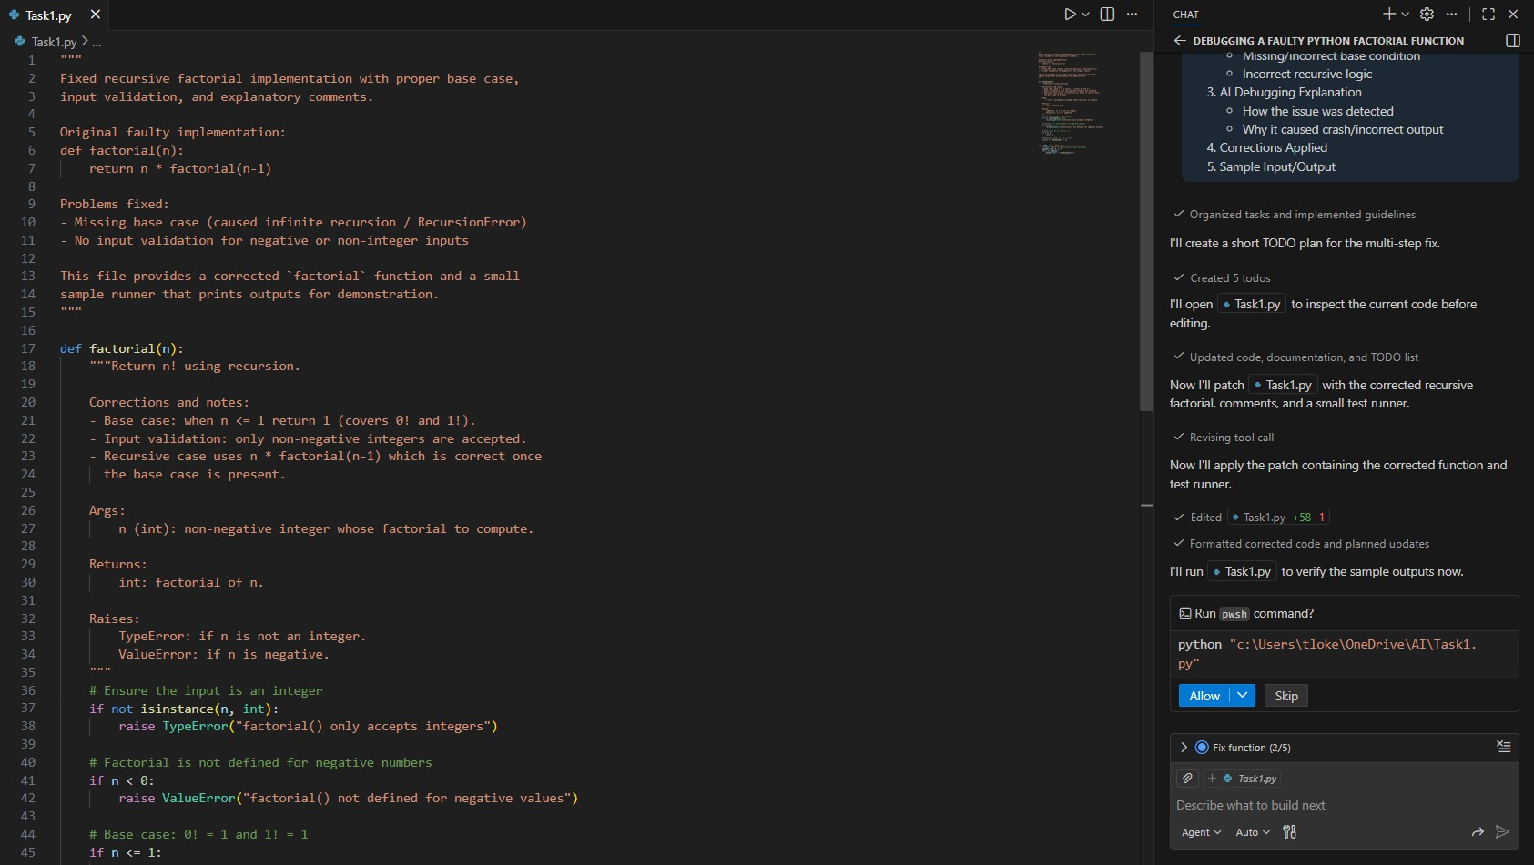
OUTPUT:
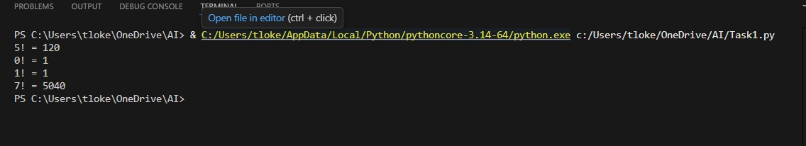
TASK-02:
Fixing Data Type Errors in a Sorting Utility
Scenario You are developing a data processing script that sorts user input values. The program crashes when users enter mixed data types.
Task Description
You are provided with a list-sorting function that fails due to a Type Error caused by mixed data types (e.g., integers and strings).Use GitHub Copilot or Cursor AI to:
- Detect the root cause of the runtime error
- Modify the code to ensure consistent sorting (by filtering or type conversion)
- Prevent the program from crashing
Explain the debugging steps followed by the AI.
Expected Outcome
- A corrected sorting function
- AI-generated solution handling type inconsistencies
- Successful sorting without runtime errors
- Explanation of how the fix improves robustness
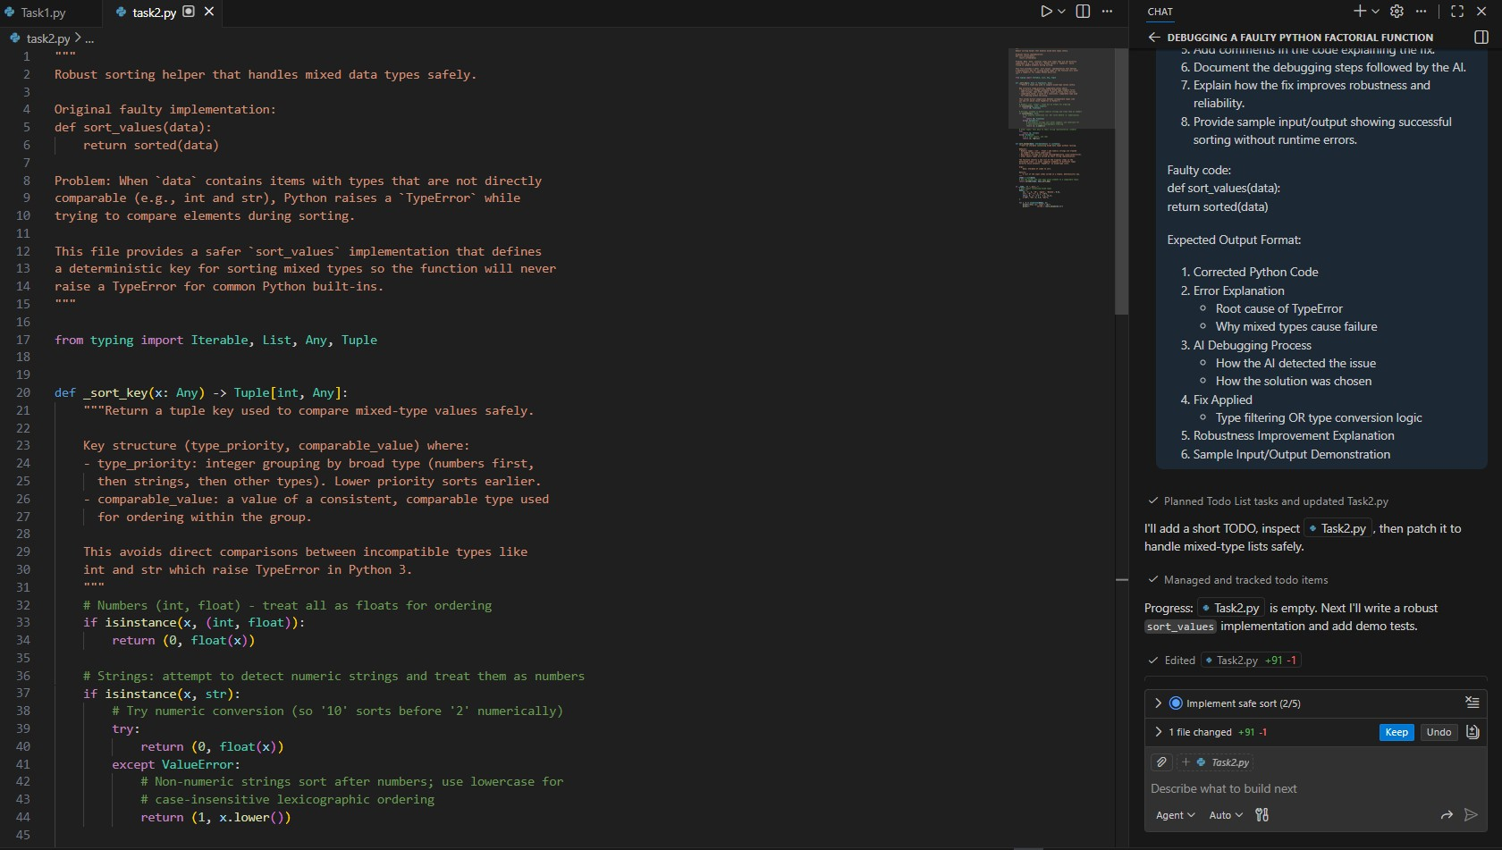
OUTPUT:
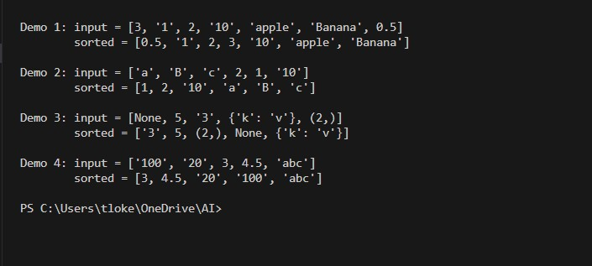

Task-03: Task 3: Improving File Handling Reliability
Scenario: A backend script reads data from files regularly. Over time, the system shows performance issues due to improper resource management.
Task Description
You are given a Python file-handling snippet that opens a file but does not explicitly close it. Use GitHub Copilot or Cursor AI to:
- Identify the potential problem in the code
- Refactor it using best practices (such as a context manager)
- Ensure safe and reliable file handling
Briefly describe why the revised approach is better.
Expected Outcome
- Refactored code using the with open() statement
- AI explanation highlighting prevention of resource leaks
- Clean execution without warnings or errors
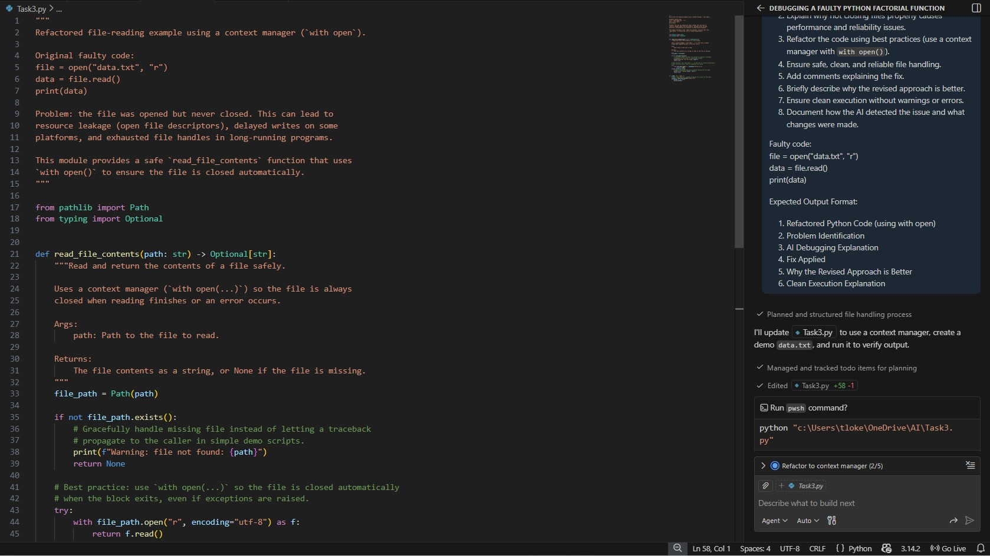
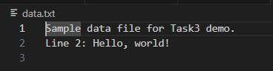
OUTPUT:
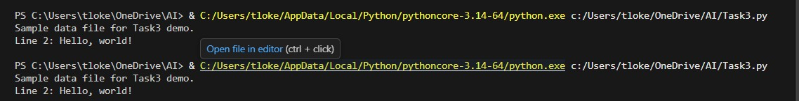

Task 4: Handling Runtime Errors Gracefully in Loops
Scenario: You are working on a data analysis script that processes a list of values. Some values cause runtime errors, but the program should continue processing remaining data.
Task Description
You are provided with a code snippet containing a ZeroDivisionError inside a loop. Use GitHub Copilot or Cursor AI to:
- Detect the exact location of the error
- Add appropriate exception handling using try-except
- Ensure the loop continues executing safely
Document how AI improved the fault tolerance of the program.
Expected Outcome
- Updated code with proper exception handling
- Meaningful error messages instead of program crashes
- Successful execution for all valid inputs
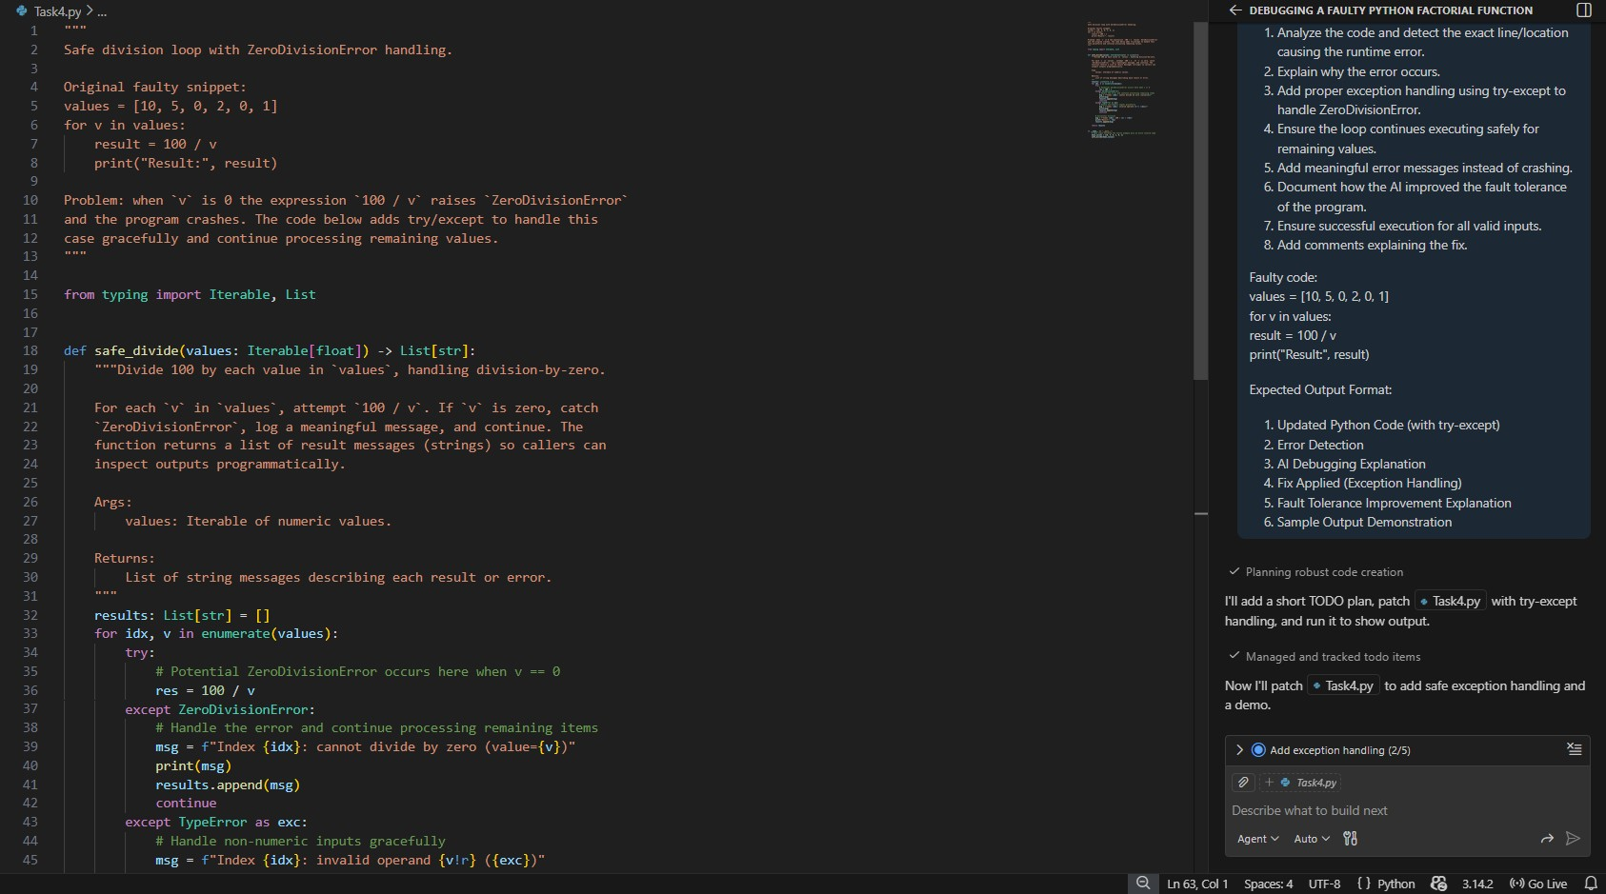
OUTPUT:
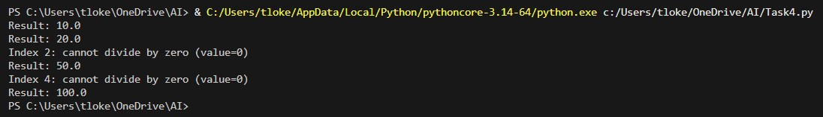

Task 5: Debugging Class Initialization Errors
Scenario: A class written by a junior developer is throwing unexpected errors when objects are created or attributes are accessed.
Task Description
You are given a Python class with:
- Incorrect __init__ parameters
- Missing or incorrect attribute references (e.g., missing self) Use GitHub Copilot or Cursor AI to:
- Analyze the class definition
- Identify constructor and attribute issues
- Correct the class so objects initialize and behave correctly
Explain the corrections suggested by the AI.
Expected Outcome
- A corrected class definition
- Proper use of self and constructor parameters
- AI-assisted explanation of the original errors and fixes
- Sample object creation and method usage
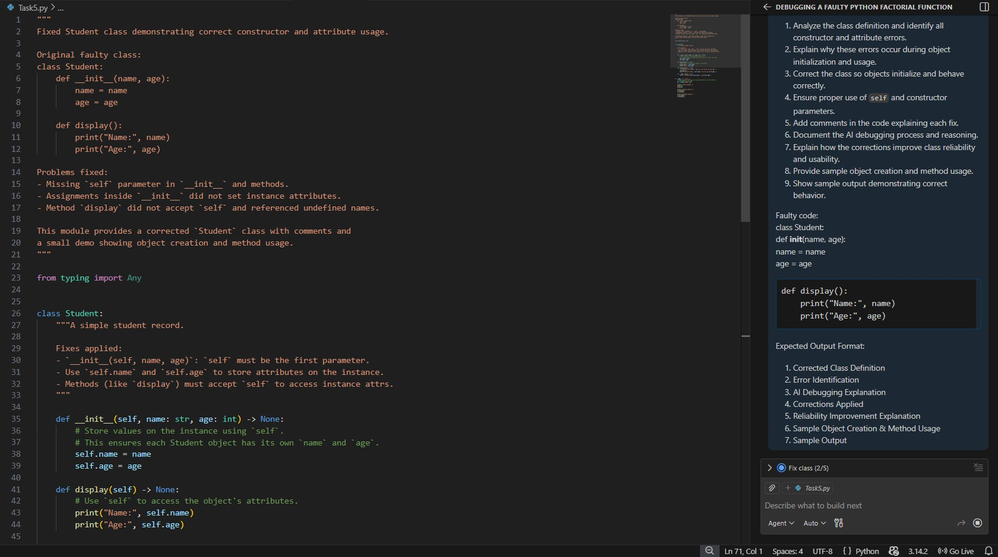
OUTPUT:
